Assignment 2: Software Requirements Specification

Team: Nostalgify

Project Title: Nostalgify

## Members:

1. Kevin Zheng
2. Audi Woodside
3. Kassem Ataya
4. Rasheed Al-Shwaf
5. Muhammad Ali
6. Parham Marzban

|  |  |
| --- | --- |
| **Meetings date** | **Participants** |
| 01/18/2024 Thursday | Kevin Zheng, Audi Woodside, Kassem Ataya, Parham Marzban, Muhammad Ali, Rasheed Al-Shwaf |
| 01/20/2024 Saturday |  |
| 02/1/2024 Thursday | Kevin Zheng, Audi Woodside, Kassem Ataya, Parham Marzban, Muhammad Ali, Rasheed Al-Shwaf |
| 02/3/2024 Saturday | Kevin Zheng, Audi Woodside, Kassem Ataya |
| 02/3/2024 Sunday | Kevin Zheng, Audi Woodside, Parham Marzban, Muhammad Ali, Rasheed Al-Shwaf |
| 02/8/2024 Thursday | Kevin Zheng, Audi Woodside, Kassem Ataya, Parham Marzban, Muhammad Ali, Rasheed Al-Shwaf |
| 02/10/2024 Saturday |  |
| 02/15/2024 Thursday | Kevin Zheng, Audi Woodside, Kassem Ataya, Parham Marzban, Muhammad Ali, Rasheed Al-Shwaf |
| 02/17/2024 Saturday |  |
| 02/22/2024 | Kevin Zheng, Audi Woodside, Kassem Ataya, Parham Marzban, Muhammad Ali, Rasheed Al-Shwaf |
| 02/24/2024 |  |
| 02/29/2024 | Kevin Zheng, Audi Woodside, Kassem Ataya, Parham Marzban, Muhammad Ali, Rasheed Al-Shwaf |
| 03/2/2024 |  |
| 03/7/2024 | Kevin Zheng, Audi Woodside, Kassem Ataya, Parham Marzban, Muhammad Ali, Rasheed Al-Shwaf |
| 03/9/2024 |  |
| 03/14/2024 | Kevin Zheng, Audi Woodside, Kassem Ataya, Parham Marzban, Muhammad Ali, Rasheed Al-Shwaf |
| 03/16/2024 |  |
| 03/21/2024 | Kevin Zheng, Audi Woodside, Kassem Ataya, Parham Marzban, Muhammad Ali, Rasheed Al-Shwaf |
| 03/23/2024 |  |
| 03/28/2024 | Kevin Zheng, Audi Woodside, Kassem Ataya, Parham Marzban, Muhammad Ali, Rasheed Al-Shwaf |
| 03/30/2024 |  |
| 04/4/2024 | Kevin Zheng, Audi Woodside, Kassem Ataya, Parham Marzban, Muhammad Ali, Rasheed Al-Shwaf |
| 04/6/2024 |  |
| 04/11/2024 | Kevin Zheng, Audi Woodside, Kassem Ataya, Parham Marzban, Muhammad Ali, Rasheed Al-Shwaf |
| 04/13/2024 |  |
| 04/18/2024 | Kevin Zheng, Audi Woodside, Kassem Ataya, Parham Marzban, Muhammad Ali, Rasheed Al-Shwaf |
| 04/20/2024 |  |
| 04/25/2024 | Kevin Zheng, Audi Woodside, Kassem Ataya, Parham Marzban, Muhammad Ali, Rasheed Al-Shwaf |
| 04/27/2024 |  |

|  |  |  |
| --- | --- | --- |
| **NFR1.** Security Implementation | | |
| Goal: The system will protect the username and password of the user. | | |
| Stakeholders: Spotify users | | |
| When the user creates their account, the program will prompt them to input their Spotify username and password. This information will be encrypted and stored for the protection of the user. | | |
| Origin: Based on initial project specification document, team members came up with this description during the first meeting. | | |
| Version: 1.0 | Date: 02/3/2024 | Priority: 5 |

|  |  |  |
| --- | --- | --- |
| **NFR2.** Protection of personal information | | |
| Goal: The app will not disclose the user's personal information. | | |
| Stakeholders: Spotify users | | |
| The app will implement strict safety measures to ensure the protection of the user's personal information. This will be done via encryption, access control, regular patching, and secure developing practices. The security put in place will comply with standard procedures regarding the collection, processing, and storage of the user's personal data. | | |
| Origin: Based on initial project specification document, team members came up with this description during the first meeting. | | |
| Version: 1.0 | Date: 02/3/2024 | Priority: 5 |

|  |  |  |
| --- | --- | --- |
| **NFR3. Nostalgify Usability** | | |
| Goal: Previous Spotify users should be able to learn how to navigate Nostalgify within five minutes of initial interaction | | |
| Stakeholders: Spotify users | | |
| Previous Spotify users who are familiar with Spotify’s interface and features will be able to easily navigate Nostalgify due to its similar categories, such as playlists, artists, albums, and liked songs. Spotify users should be able to become familiar with the application within five minutes. | | |
| Origin: Based on initial project specification document, team members came up with this description during the first meeting. | | |
| Version: 1.0 | Date: 02/3/2024 | Priority: 3 |

|  |  |  |
| --- | --- | --- |
| **NFR4. Availability with Wi-Fi** | | |
| Goal: Nostalgify will be accessible with Wi-Fi 99% of the time | | |
| Stakeholders: Spotify users | | |
| While connected to Wi-Fi, Nostalgify should be able to run 99% of the time without any crashes or issues. | | |
| Origin: Based on the initial project specification document, team members came up with this description during the first meeting. | | |
| Version: 1.0 | Date: 02/3/2024 | Priority: 4 |

|  |  |  |
| --- | --- | --- |
| **NFR5. Photo Upload Performance** | | |
| Goal: An image from the device’s photo gallery shall upload to Nostalgify within 3 seconds | | |
| Stakeholders: Spotify users | | |
| When uploading a picture from the photo gallery within Nostalgify, the picture should not take longer than 3 seconds to upload to a specific song’s folder. | | |
| Origin: Based on initial project specification document, team members came up with this description during the first meeting. | | |
| Version: 1.0 | Date: 02/3/2024 | Priority: 2 |

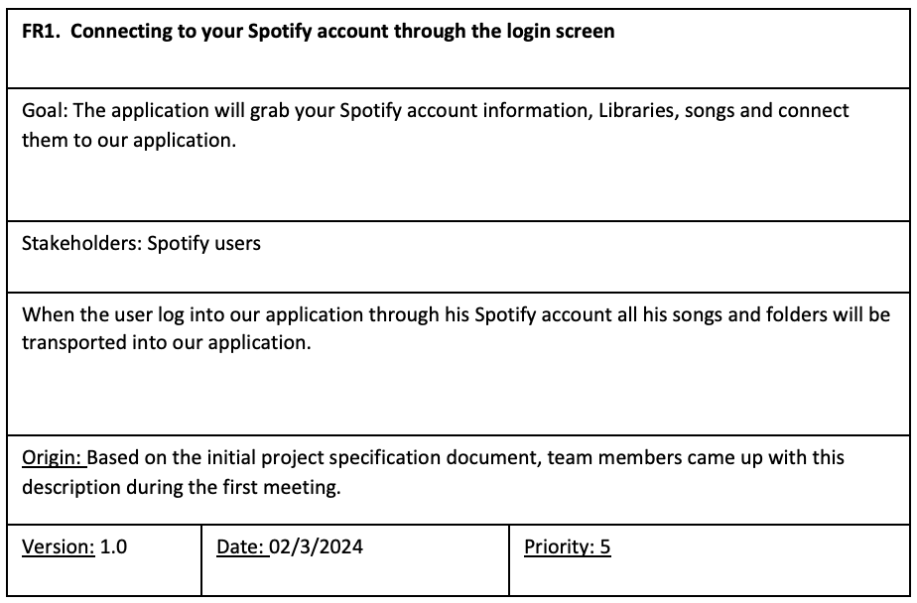

|  |  |  |
| --- | --- | --- |
| **FR3.** Take and save pictures within Nostalgify to current song that is being played | | |
| Goal: When a picture is taken within Nostalgify, a picture will be uploaded to the currently listened to song’s folder. | | |
| Stakeholders: Spotify users | | |
| After the camera is accessed (see FR12.), taking a picture through the camera on Nostalgify will automatically save the picture into the currently listened to song’s folder within the app. If there is no currently listened to song, the user can choose which folder to place it in. | | |
| Origin: Based on initial project specification document, team members came up with this description during the first meeting. | | |
| Version: 1.0 | Date: 02/3/2024 | Priority: 5 |

|  |  |  |
| --- | --- | --- |
| **FR4. Tag songs with customized tags** | | |
| Goal: Team members came up with this description during the first meeting. | | |
| Stakeholders: Spotify users | | |
| Users can assign custom tags to songs via input, enabling them to categorize and filter their music based on personalized criteria. | | |
| Origin: members came up with this description during the first meeting. | | |
| Version: 1.0 | Date: 02/4/2024 | Priority: 3 |

|  |  |  |
| --- | --- | --- |
| **FR5. Search songs via tag(s)** | | |
| Goal: Enable users to efficiently search for songs based on customized tags assigned to them. | | |
| Stakeholders: Spotify users | | |
| Users: Users can utilize a search functionality within the app to find songs by entering or selecting customized tags, allowing users to quickly locate songs associated with specific themes, moods, or categories. | | |
| Origin: team members came up with this description during the first meeting. | | |
| Version: 1.0 | Date: 02/4/2024 | Priority: 4 |

|  |  |  |
| --- | --- | --- |
| **FR6. Access user’s Spotify playlists** | | |
| Goal: Allow seamless access to and integration with the user's Spotify playlists within the app. | | |
| Stakeholders: Spotify users | | |
| Users: Provide read-only access to their Spotify playlists. This feature enables users to browse, launch spotify app for playback, and manage app-side playlist directly from the app. | | |
| Origin: team members came up with this description during the first meeting. | | |
| Version: 1.0 | Date: 02/4/2024 | Priority: 2 |

|  |  |  |
| --- | --- | --- |
| **FR7. Access user’s Spotify albums** | | |
| Goal: Improve user convenience by allowing direct access to and integration with the user's Spotify albums within the app. | | |
| Stakeholders: Spotify users | | |
| Users: Provide read-only access to their Spotify albums. This feature enables users to browse, launch Spotify app for playback, and manage app-side playlist directly from the app. | | |
| Origin: team members came up with this description during the first meeting. | | |
| Version: 1.0 | Date: 02/4/2024 | Priority: 1 |

|  |  |  |
| --- | --- | --- |
| **FR8.** Access user’s Spotify artists | | |
| Goal: Show user’s followed artists | | |
| Stakeholders: Spotify’s Users | | |
| Users can see their followed Spotify artists and their liked songs from those artists. | | |
| Origin: Based on the initial project specification document, team members came up with this description during the first meeting. | | |
| Version: 1.0 | Date: 02/4/2024 | Priority: 2 |

|  |  |  |
| --- | --- | --- |
| **FR9.** Access user’s Spotify liked songs | | |
| Goal: Show user’s Spotify liked songs playlist | | |
| Stakeholders: Spotify’s Users | | |
| Users can see their liked songs playlist from Spotify | | |
| Origin: Based on the initial project specification document, team members came up with this description during the first meeting. | | |
| Version: 1.0 | Date: 02/4/2024 | Priority: 2 |

|  |  |  |
| --- | --- | --- |
| **FR10.** Selection of color palettes for folders | | |
| Goal: Allow users to choose from selection | | |
| Stakeholders: Spotify’s Users | | |
| Users can choose from a selection of color palettes for each folder | | |
| Origin: Based on the initial project specification document, team members came up with this description during the first meeting. | | |
| Version: 1.0 | Date: 02/4/2024 | Priority: 2 |

|  |  |  |
| --- | --- | --- |
| **FR11.** Tapping photo gallery button on navigation bar will open user’s photo gallery | | |
| Goal: Allow users to open their photo gallery from the app | | |
| Stakeholders: Spotify’s Users | | |
| Users can open their photo gallery from the app to choose photos to upload | | |
| Origin: Based on the initial project specification document, team members came up with this description during the first meeting. | | |
| Version: 1.0 | Date: 02/4/2024 | Priority: 4 |

|  |  |  |
| --- | --- | --- |
| **FR12.** Tap on camera button opens camera | | |
| Goal: allow user to access the camera | | |
| Stakeholders: Spotify users | | |
| In the menu, the user will have access to the camera button which allows them to access their camera for videos and photos. These media sources will then be uploaded to their profile. | | |
| Origin: Based on the initial project specification document, team members came up with this description during the first meeting. | | |
| Version: 1.0 | Date: 02/4/2024 | Priority: 4 |

|  |  |  |
| --- | --- | --- |
| **FR13.** User icon leads to settings | | |
| Goal: allow user to access the settings | | |
| Stakeholders: Spotify users | | |
| In the menu, the user will be able to access the settings through the user icon. This will allow them to adjust the display, profile, and sound. | | |
| Origin: Based on the initial project specification document, team members came up with this description during the first meeting. | | |
| Version: 1.0 | Date: 02/4/2024 | Priority: 3 |

|  |  |  |
| --- | --- | --- |
| **FR14.** Search icon will take you search bar | | |
| Goal: allow user to access the search feature | | |
| Stakeholders: Spotify users | | |
| In the menu, the user will be able to access the search bar to search through various media saved in their profile and be able to access specific songs and media. | | |
| Origin: Based on the initial project specification document, team members came up with this description during the first meeting. | | |
| Version: 1.0 | Date: 02/4/2024 | Priority: 4 |

|  |  |  |
| --- | --- | --- |
| **FR15.** Navigation Function | | |
| Goal: The system will allow users to swipe to navigate between screens. | | |
| Stakeholders: Spotify users | | |
| When a user swipes left/right on the screen, it will send them to the next screen as indicated by the navigation bar. The icon on the bar will then highlight the current function of the screen and the user will be able to proceed with their next task. | | |
| Origin: Based on initial project specification document, team members came up with this description during the first meeting. | | |
| Version: 1.0 | Date: 02/3/2024 | Priority: 2 |